Recently, the CQI system identified an increase in the number of reports of periorbital skin injuries related to the use of Tegaderm for eye protection. It was discovered that a different version of Tegaderm had entered the anesthesia supply chain without notice. Tegaderm HP “Holding Power” has a different, stronger adhesive than standard Tegaderm, and is intended for use in areas where moisture is present. 3M Healthcare has stated that Tegaderm HP, “should not be used in areas where the dressing would be changed before 7 days.”
The Tegaderm HP can be identified by its packaging.
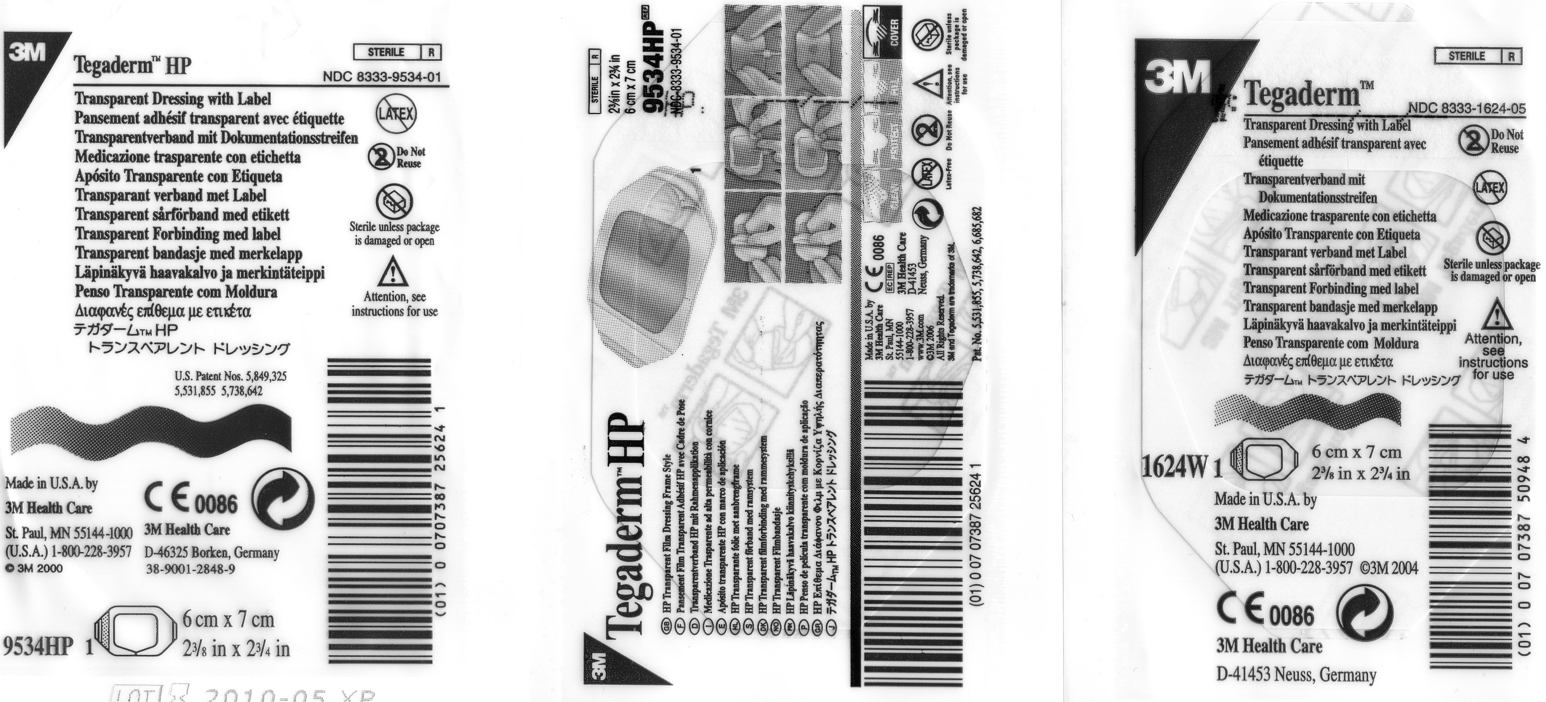
Tegaderm HP Tegaderm HP – alternate package Standard Tegaderm
Tegaderm HP has been removed from the OR anesthesia carts to avoid potential for confusion, however, it is still stocked in the pre-op area. Anesthesia providers should be aware that the two versions exist, and that the HP version is not appropriate for use as eye protection.

